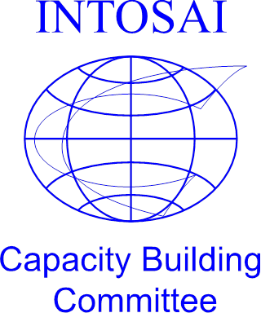

**1st meeting of the full**

**Task Force on INTOSAI Auditor Professionalisation**

**Date**: Friday, 22 September 2017

**Time**: 09:00 – 16:00

**Venue**: Washington, DC (exact venue to be confirmed)

**Agenda**

|  |  |  |
| --- | --- | --- |
| **Time** | **Activity** | **Main documentation** |
| 09:00 – 09:30 | Opening, introductions and report on the meeting in Brasilia of June, 5th– 6th | TFIAP Strategic Concept 2017-2019 (version 2) |
| 09:30 – 12:00 | Work Stream 1: *Framework for Professional Development Initiatives (FPDI) at SAIs* – introduction and detailed discussion (this work stream will anchor the work of the TFIAP) | FPDI process flow diagram |
| Work stream 2: *INTOSAI Competency Framework* – refinement of existing ‘INTOSAI Competency Framework for Public Sector Audit Professionals’ | INTOSAI Competency Framework (revised to include ISSAI references) |
| 12:00 – 13:00 | *LUNCH* |  |
| 13:00 – 15:00 | Work stream 3: *Identification of competencies for SAIs with jurisdictional powers* – how best to ensure inclusion of relevant competencies in final ‘INTOSAI Competency Framework’ | To be confirmed |
| Work stream 4: *Best practice guide for competency-based HR practices* – discussion on scope and approach to develop such a best practice guide | To be confirmed |
| 15:00 – 16:00 | Conclusion and way forward | |