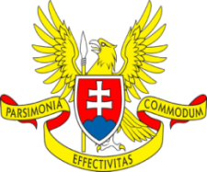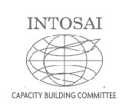
Sub-Committee on Peer Reviews
Sub-Committee meeting programme
Finlandshuset, Stockholm, Sweden
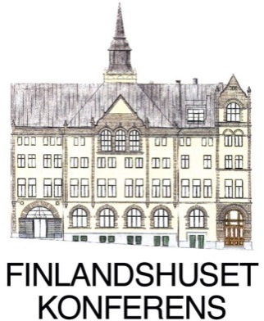

Tuesday, 8th September 2015, 10:45 – 12:30

1. Information on SC PR activities since the last meeting 2014 in Lima
- The membership
- Glossary – SAI of Mexico
- The peer review survey within INTOSAI community 2015, its assessment and results
- The peer review and ISSAI 5600 promotion since Lima meeting
- SC PR cooperation with SAI of Austria – global peer review on independence
- Open discussion on SC PR activities, observations by the SC PR members

2. Revised INOSAI 5600 – preparation for endorsement draft and INCOSAI 2016
- The presentation of the revised standard
- Milestones for the draft endorsement
- Open discussion on the subject, observations by the SC PR members

3. New strategic development of the SC PR after 2016
- suggestions by the Chair and the SC 3 members

