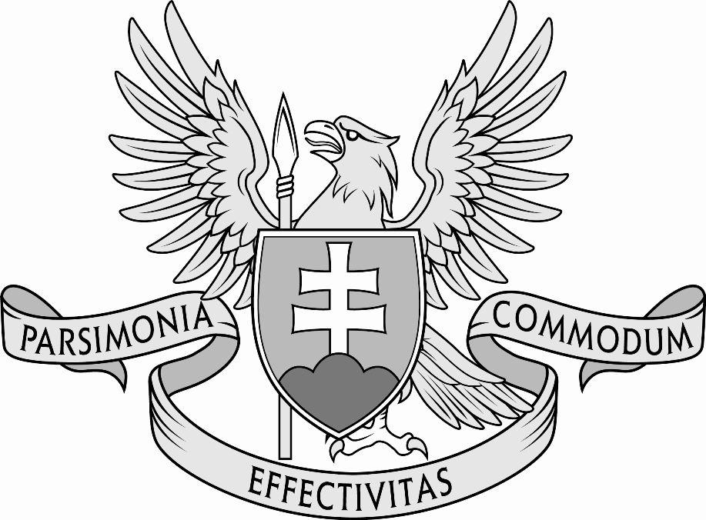
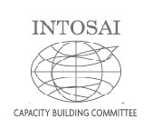

INTOSAI Capacity Building Committee

Sub-Committee 3

Promote Best Practices
and Quality Assurance through Voluntary Peer Reviews

Report
to the 66th INTOSAI Governing Board

Vienna, Austria
November 2014

Supreme Audit Office of the Slovak Republic (SAI of Slovakia)
e-mail: info@nku.gov.sk
Annexes
1. Executed Peer Reviews overview
2. SC 3 Action Plan 2013 – 2016
3. ISSAI 5600 revision milestones
4. E-mail peer review survey questionnaire
I. Tasks
According to the INTOSAI Strategic Plan 2011 – 2016, the Goal 2 states that Sub-Committee will promote the best practices and quality assurance through voluntary peer reviews. To achieve this goal the Sub-Committee
a. continues to assess and document existing peer review arrangements in the INTOSAI community;
b. continues to foster an environment where such voluntary reviews are seen as beneficial to both the SAI undertaking the review and the SAI choosing to undergo it and establish global and regional mechanisms for initiating peer reviews;
c. where necessary, updates the CBC guidelines on peer reviews and the developed checklist on the basis of the experience of SAIs and provides further good practices on how to undertake voluntary peer reviews;
d. disseminates the results of peer reviews, as appropriate and as agreed by participating SAIs

II. Members, cooperating organisations and partners
Members to date (13):
Austria, Bangladesh (Vice Chair), Croatia, European Court of Auditors, Estonia, Germany, Hungary, Indonesia, Morocco, Poland, Slovak Republic (Chair), Sweden, United States of America
Cooperating organisations and partners (3):
IDI, OECD, SAI of Switzerland
note: Sweden became regular member after organisational changes in the CBC at the XXI INCOSAI in Peking 2013 that saw approval of the SAI of Sweden as the CBC Vice-Chair.

III. Sub-Committee meetings
The Sub-Committee meetings up to date:
- 14. June 2007, Bonn, Germany
- 27. August 2008, Bonn, Germany
- 20. – 21. May 2010, Bonn, Germany
- 08. – 09. September 2011, Vienna, Austria
- 10. – 11. September 2012, Luxembourg, Luxembourg
- 13. – 14. June 2013, Bratislava, Slovakia
- 09. – 11. September 2014, Lima, Peru (as part of CBC yearly meeting)
IV. Current status
The Supreme Audit Office of the Slovak Republic became the Chair to the INTOSAI CBC´s Sub-Committee 3 Promote best practices and quality assurance through voluntary peer reviews (further Sub-Committee 3) on 19 - 22 November, 2012 at the 63rd Governing Board meeting succeeding the SAI of Germany. It is discharging its duties according to the CBC Terms of Reference, INTOSAI Handbook for INTOSAI Committees, Strategic plan 2011 – 2016 and other relevant INTOSAI documents and practice.
The Sub-Committee has also established the ISSAI 5600 revision Task Team (TT) that comprises representatives from SAIs of Germany, Hungary, Poland and Slovakia. The TT aims to meet at least once a year according to ist members availability. The TT met:
- 20. – 22. March 2013, Bonn, Germany
- 11. – 13. August 2013, Cracow, Poland
- 11. – 13. May 2014, Bratislava, Slovakia

1) Tasks a. and d.: Assess and document existing peer review arrangements and disseminate peer review results
As of November 2014, the Sub-Committee is informed about 70 completed, ongoing or planned peer review projects (annex 1). The increase by 18 projects within 12 months since XXI INCOSAI 2013 was not due to sharp increase of new projects only but mainly due to finding the peer review reports from the past not published so far.
The peer review documentation with the Sub-Committee currently comprises of 41 peer review final reports (35 in English, 4 in Spanish and 2 in German), 7 Memoranda of Understanding, and other varied materials.
Since November 2011, the documentation is published on the CBC website. To manage and develop the documentation, the Sub-Committee carries out an email survey addressed to all INTOSAI members. The e-mail questionnaire has been distributed for the first time in December 2011. The recent e-mail survey was carried out in January to March 2014. Some facts and conclusions arising from the survey:

A. Peer review survey process
- The survey was executed between January 13th and March 31st, 2014in accordance with the CBC Subcommittee 3 Action Plan 2013-2016 and its strategy that states a. Continue to assess and document existing peer review arrangements in the INTOSAI community.
- The INTOSAI members were delivered a questionnaire with the peer review topic via e-mail.
- At the e-mail execution, INTOSAI membership according to data at the INTOSAI web page http://www.intosai.org/about-us/organisation/membership-list.html were 191 SAIs (note: the present number is 192);
- INTOSAI members without web page: 40 (Aruba, Antigua and Barbuda, Bahamas, Belarus, Burundi, Cameroon, Cabo Verde, Central African Republic, Chad, Congo, Djibouti, Equatorial Guinea, Eritrea, Gabon, Gambia, Ghana, Grenada, Guinea, Guinea-Bissau, Haiti, Holy See, Laos, Libya, Madagascar, Malawi, Mali, Monaco, Nauru, Netherlands Antilles, Saint Kitts and Nevis, Sao Tomé and Principe, Somalia, Sudan, Suriname, Swaziland, Syrian Arab Republic, Togo, Tonga, Tuvalu, Vanuatu).
- More SAIs have e-mail contact than their respective web page.
- INTOSAI members without any e-mail contacts to sent the questionnaire to: 4 (Equatorial Guinea, Guinea, Guinea-Bissau, Somalia)
- Questionnaire was undeliverable (according to the web servers) to: 17 SAIs (varied reasons, mainly the address was incorrect, not valid address etc).
- From the above, an assumption can be generated that the questionnaire was sent and received at 170 SAIs (191 SAIs less 4 INTOSAI members without any e-mail contact and less 17 INTOSAI members when the questionnaire was undeliverable).
- The Subcommittee registered 46 replies e.g. rate of return was around 28 %.

B. Peer review survey findings
- As of April 1st, 2014, in total 66 peer review projects made and/or planned in the period 1999 – 2014 were known to the Subcommittee.
- The Subcommittee report to the XXI. INOCOSAI in October 2013 stated, that the Sub-Committee was informed about 52 completed, ongoing or planned peer review projects to the date.
- The increase by14 projects within 6 months since XXI. INCOSAI was not due to new projects but mainly due to finding the peer review reports from the past going as back as to the year 1999.
- The most reviewed SAI were GAO US that has to be reviewed every 3 years according to the US law – it was reviewed 4 times. Another 3 countries were peer reviewed three times: Canada, Lithuania and Poland. Fourteen countries were reviewed twice and another 25 countries were peer reviewed once.
- The largest number of peer reviews were conducted in 2012 – 12. The second richest year for the peer reviews appears to be the year 2014 when 8 peer reviews were to be executed. To the contrary – no peer reviews were registered in the year 2002 and 2003. In the followed period (1999 – 2014) there were 4.4 peer reviews recorded in the INTOSAI community on average per year.
- SAI of Sweden were involved in peer review as peer reviewer 18 times, followed by Norway (17 times) and Netherlands along with UK (16 times). These four SAIs accounted for 41 % of the engagements of the SAIs in the peer review as peer reviewers.
- There were 6 SAIs engaged as peer reviewers between 5 to 9 times (in decreasing order) - Denmark, France, Germany, ECA, Canada and Australia. There were another 24 SAI engaged in peer reviews in lesser numbers than 5 times.
- Average size of the peer reviewing team: 5.7 people per team
- Average number of days of the reviewing team spent at the reviewed SAI premises: 13.5
- There are 41 peer review reports available: 35 in English, 4 in Spanish and 2 in German.
- Topics and scope of the peer review varied widely according to the peer review goal. They were like: management and organizational setup (core audit, administrative and management functions); legal framework; audit methodology, standards and manuals; planning and quality control; new types and areas for audit; making use of audit findings; auditors and SAIs staff training and development; assessment whether the performance auditing practice provides Parliament/legislative branch with independent, objective and reliable information on government performance; assessment of compliance with ISSAIs and best practice, providing opinion on the system of quality assurance; assessment of reviewed SAI strategic and operational planning, quality management, etc.
- Number and types of recommendations also varied widely according to the peer review goal and findings. They ranged from several recommendations to many dozens, from very specific to more general. The recommendations from the individual peer review have to be taken within the given peer review framework and circumstance.
- The peer review recommendations use and their fulfilment was difficult to observe, as majority of the peer reviews weren´t followed by the follow-up procedures, process etc. or at least the Subcommittee wasn´t made aware or didn´t manage to collect more information on the finished peer reviews that would cover the periods after the peer review and use and application of the recommendations.

2) Task b.: Foster environment where voluntary peer reviews are seen as beneficial
In order to promote voluntary peer reviews and general knowledge about them among the INTOSAI community and wider public, the Sub-Committee informed the INTOSAI community members on the progress made in the Sub-Committee work on the ISSAI 5600 revision and the e-mail survey results in the INTERNATIONA JOURNAL of GOVENMENT AUDITING in its July edition in the article The peer reviews numbers on rise.
The Sub-Committee Chair representatives gave presentation on the topic of ISSAI 5600 at the Slovak Institute of Internal Auditors conference in September 2014 in Bratislava titled ISSAI 5600 – its application and benefits.
It remains crucial that the Heads of SAIs are convinced of peer reviews benefits and perceive the ISSAI 5600 as valuable peer review tool that help to improve the SAI´s quality of work including the effectiveness, efficiency and economy.
The Sub-Committee is keen to provide INTOSAI members with detailed information on its activities. Therefore, all pertinent Sub-Committee documents are to be published at the CBC website in 2014 and following time.

3) Task c.: Update the peer review guidelines and provide best practice examples
Peer Review Guide and Checklist:
The XX INCOSAI endorsed the Peer Review Guide with the Checklist developed by the Sub-Committee as ISSAI 5600 in 2010. This document has been translated into all INTOSAI official languages: Arabic, English, French, German, and Spanish; also working versions of other languages were made, so far in Bengali, Hungarian, Mandarin, Portuguese, and Slovak.
All SAIs are invited to share information on their experience with the two documents and to make proposals for improvement and modification.
According to INTOSAI Due process for INTOSAI professional standards - Procedures for developing, revising and withdrawing International Standards of Supreme Audit Institutions (ISSAIs) and INTOSAI Guidance for Good Governance (INTOSAI GOVs), the Sub-Committee has decided to present a revised ISSAI 5600 to the XXII INCOSAI in 2016.
The revised ISSAI 5600 was the Sub-Committee meeting focal point in Bratislava in 2013 when Sub-Committee members have endorsed further steps and decided on the SAIs responsible for developing the particular chapters (European Court of Audits and SAIs of Austria, Germany, Hungary, Poland, Slovakia, Sweden).
The revised ISSAI 5600 structure:
chapter | present ISSAI 5600 | chapter | revised ISSAI 5600 | revised chapter author
preface | preface | preface | preface | SAI of Germany
1 | Introduction | 1 | Introduction and scope of ISSAI | SAI of Germany
2 | Definition | 2 | Definition | SAI of Germany
3 | Initial consideration | 3 | Strategic consideration | SAI of Sweden
4 | Peer review agreement (MoU) | 4 | Preparation
 |  |  | A. Peer review areas | SAI of Hungary
 |  |  | B. Selection of partners | ECA
 |  |  | C. Self assessment tools | SAI of Sweden
 |  |  | D. Resources | ECA
5 | Preparation and conduct | 5 | Memorandum of Understanding | ECA
6 | Follow-up and Evaluation | 6 | Peer review work planning | SAI of Slovakia
 |  | 7 | Field work | SAI of Slovakia
 |  | 8 | Peer review report | SAI of Poland
 |  | 9 | Implementation of results | SAI of Austria
 |  | 10 | Follow up | SAI of Austria
 | glossary of terms |  | glossary of terms | SAI of Slovakia
pages | 46 |  | app. 37
The Sub-Committee also established Task Team ISSAI 5600 (TT) composed from the representatives from the SAIs of Germany, Hungary, Poland and Slovakia. TT meets usually once a year (the last meeting was in Bratislava in May 2014, other communication is executed electronically).
The Checklist was deemed of being too prescriptive and having feeling of being compulsory rather than offering suggestions; it was renamed as Peer Review Questions that offer inspiration to the peer review parties. As the peer review questions might change over time (more often than the Guide) and they might require greater flexibility and options to include or omit some of them, it was suggested to have Peer Review Questions published on the CBC web site and not as firm part of the Guide itself. The Guide would only direct the reader and possible user to the CBC web site where the whole list of Peer Review Questions would be published.

4) Other issues:
Disseminate the peer review results
The broader and more detailed presentation of the peer review results weights for varied reasons largely on the internet use and is heavily depending on functional CBC web site. Therefore it might be achievable to disseminate the information and news on peer review within the INTOSAI community directly to their potential users targeting the key people from the individual SAIs.
SAI Performance Measurement Framework (SAI PMF)
The SAI of the Slovak Republic carried out the pilot testing of SAI PMF, using draft version 2.1 in 2013 and applied it for self assessment. At the Sub-Committee meeting in June 2013 in Bratislava it was agreed that the IDI will keep the Sub-Committee members informed on the progress on the SAI PMF. Presentation of the Slovak experience with the SAI PMF was delivered at the September 2014 CBC meeting in Lima, Peru.

V. The future tasks
The future tasks of Sub-Committee are defined in its Action Plan 2013 - 2016 (Annex 2):
- to continue to develop and update the peer review documentation;
- to continue to revise ISSAI 5600 according to the Due Process for INTOSAI professional standards with the goal to present it at INCOSAI 2016;
- to continue to promote peer review as a tool for quality assurance and capacity building within the INTOSAI community;
- to fulfil tasks arising from the conclusions adopted at the meeting in Lima that were as follows:
The SC 3 has decided to:
- secure regular update of information and news on peer review reports within the INTOSAI community to be published onto the new CBC web site;
- publish the results of the peer review survey recommendations in one of the CBC external communication mode;
- execute survey of SAIs willingness to perform peer review while specifying the expert areas they would be able joint the peer review (to specify the expert areas where they would be able/willing to offer their capacities);
- further discuss in cooperation with the involved parties to re-direct the SC 3 activities to support the effective use of the external and internal assessment tools for the SAIs capacity building in the INTOSAI Strategic plan 2016 – 2021.

