IntoSAINT Post

December 2014
IntoSAINT is a self-assessment instrument for SAIs that they can use to analyse their integrity risks and assess the maturity level of their integrity management systems.  An IntoSAINT moderator can facilitate an integrity self-assessment for a Supreme Audit Institution. The self-assessment takes place in a structured two-day workshop. The instrument is targeted at corruption prevention and leads to management recommendations to support the integrity of the organisation. The self-assessment results in a report that enables the Supreme Audit Institution to design a tailor made integrity policy and at the same time increase the integrity awareness of employees.  IntoSAINT was developed by the Netherlands Court of Audit. We support the use of the instrument internationally. Are you interested? For additional information about IntoSAINT, or if your SAI would be interested in a moderator training or an IntoSAINT workshop, please contact i.dehaan@rekenkamer.nl or m.wilbrink@rekenkamer.nl or m.janson@rekenkamer.nl | GAIN: a Guideline for Auditing INtegrity  During the last years the Netherlands Court of Audit cooperated with  AFROSAI-E, and the EUROSAI Taskforce on Audit & Ethics (TFAE) to develop a new guideline for integrity-audits.  The guideline is based on the Into-SAINT methodology and aims at mapping the vulnerabilities of organisations and at assessing the quality of the integrity controls. An advantage of IntoSAINT is the preventative approach toward integrity breaches, such as fraud and corruption. The same goes for the new guideline. Interested? Please contact i.dehaan@rekenkamer.nl or m.janson@rekenkamer.nl.  ISSAI 30  The Code of ethics revision team, in which SAI’s from all over the world are represented, had started preparations for a revision of ISSAI 30 – code of ethics in 2014. A draft for a new code of ethics will be presented in 2015.  The ambition is to write a code that is can be applied directly, yet is not too detailed. The key principles of ISSAI 30 are still valid and will therefore remain, but the scope will be broadened to all persons that work in SAI’s and the SAI itself.  IntoSAINT in SAI-PMF  IntoSAINT contributes to the capacity-building of SAIs and has an impact on their performance as organizations that must lead by example. Regarding this, IntoSAINT is already considered as an indicator in the Performance Measurement Framework of Supreme Audit Institutions (SAI-PMF), specifically in the indicator SAI-18: "Ethics, Management and Internal Control." The consideration (and application) of values and principles that guide the daily work of auditors to ensure that their conduct is beyond reproach at all times and in all circumstances (ISSAI 30) is fostered by IntoSAINT. This affects positively the SAIs’ performance.  Therefore, during the 7th Meeting of the Working Group on the Value and Benefits of SAIs, held in Mexico City in September 2014, the members of the Working Group agreed to add IntoSAINT to the follow-up agenda, in order to follow the implementation of the tool in the INTOSAI community, due to the relevance of the principles established in the ISSAI 12. This took a step forward during the 66th Meeting of the INTOSAI Governing Board, held in Vienna, Austria, in November 2014: the tool was recognized as a capacity-building tool, and the encouraging of its implementation between the INTOSAI-member SAIs was endorsed. This way, it is expected that INTOSAI-member SAIs continue moving forward in their path of consolidation as model organizations that lead by example!  IntoSAINT on the work plan INTOSAI Capacity Building Committee  During the last the Annual CBC Meeting held in Lima, Peru, from 9-11 September 2014, it was decided to include IntoSAINT in the CbC workplan.  The goal is to promote IntoSAINT as a capacity development tool.  A small sub-group will take it on them to further develop a proposal for the further dissemination and strengthening of IntoSAINT.  The leader of the project group will be The Netherlands Court of Audit. Members of the group are the audit offices of the European Union (ECA), Indonesia (link to ASEANSAI and ASOSAI), Mexico (link to WGVBS and OLACEFS), Hungary (link to EUROSAI),Tunisia (ARABOSAI), Cameroon (AFROSAI), Fiji (PASAI), AFROSAI-E, and IDI.  The proposal will focus on rolling out the IntoSAINT instrument, moderator facilities, evaluation and follow-up system within all regions, as well as identifying the best existing forum at the international level for sharing experiences and updating the tool at regular intervals. The funding issue will also be addressed. The proposal will be ready by September 2015, with a progress report to next CBC meeting in March 2015.  The overall aim is the institutionalization of IntoSAINT within INTOSAI structures by 2016.  Study Integrity Management by SAI Sint Maarten  The final report “Baseline Study on Institutional Integrity Management” was presented to the president of Parliament, on Wednesday April 16th 2014 by the  chairman of the General Audit Chamber, Mr. Ronald Halman. The Baseline Study provides the state of affairs with regard to laws and regulations related to (aspects of) integrity.  Findings  A main finding of the study is that the basic “infrastructure” of organic legislation related to integrity management is in order. However, few, if any formal regulations in the area of integrity are being implemented. Moreover, almost none of the additional rules and regulations containing specific norms that are required (in the form of ordinances) exist.  The report is extensive and outlines many other aspects of integrity, and provides additional findings related to the existence and enforcement of integrity rules. Recommendations are issued as part of the report as well.  The Baseline Study is published in both English and Dutch and is available via the website: www.arsxm.org.  EU integrity watch  EU Integrity Watch is a user-friendly interactive database that provides a unique overview of the activities of members of the European Parliament. By simply clicking on the graphs or the list below users can rank, sort and filter MEPs. Thereby the database allows to better monitor potential conflicts of interests or to identify those MEPs with more outside activities with the help of the External Activity Indicator (EAI).  http://www.integritywatch.eu/  Next IntoSAINT Post  If you have contributions, please send them to Intosaint@rekenkamer.nl.

News from the regions

AFROSAI
Uganda
In June 20214 the SAI of Uganda held an IntoSAINT workshop. The workshop was moderated by Gorden Amon Kandoro (AFROSAI-E) and Ramoganyaka Itumeleng Lesego (SAI South Africa). The 22 staff-members who attended the workshop came from all Directorates of the audit with participation of staff from Corporate Services Division. The participants found the workshop very useful and were greatly inspired. Vulnerability enhancing factors were such as complexity of teammate, the big number of new recruited staff and the outsourcing of work. Participants also pointed out issues relating to change management. The integrity control system needs improvements and recommendations were formulated to bridge the gap. The need for periodic review of progress was emphasized. The IntoSAINT workshop was highly appreciated by top management of the OAG Uganda for raising awareness as well as formulating recommendations for improvement. The willingness of the management to change is very high. To start the change process, the management of the OAG is very interested in best practices. If you have any ideas you would like to share, please send your information to maxwell.ogentho@oag.go.ug and to m.janson@rekenkamer.nl.

ASEANSAI
Moderatortraining
From 1-6 December the ASEANSAI training committee organised the first IntoSAINT moderator training for the region. The training took place in Nha Trang, was hosted by SAI Vietnam and sponsored by GIZ. The trainers were from Indonesia, The Netherlands and Vietnam. Participants came from Cambodia, Indonesia, Vietnam, Laos PDR, Philippines and Fiji. After a week of hard work all 19 participants passed their test and are now part of the family of IntoSAINT moderators. The Philippines, on behalf of the ASEANSAI training committee, together with the Chair Indonesia, will take the lead in the regional roll-out, with the support of GIZ. Congratulations to all for this excellent result!

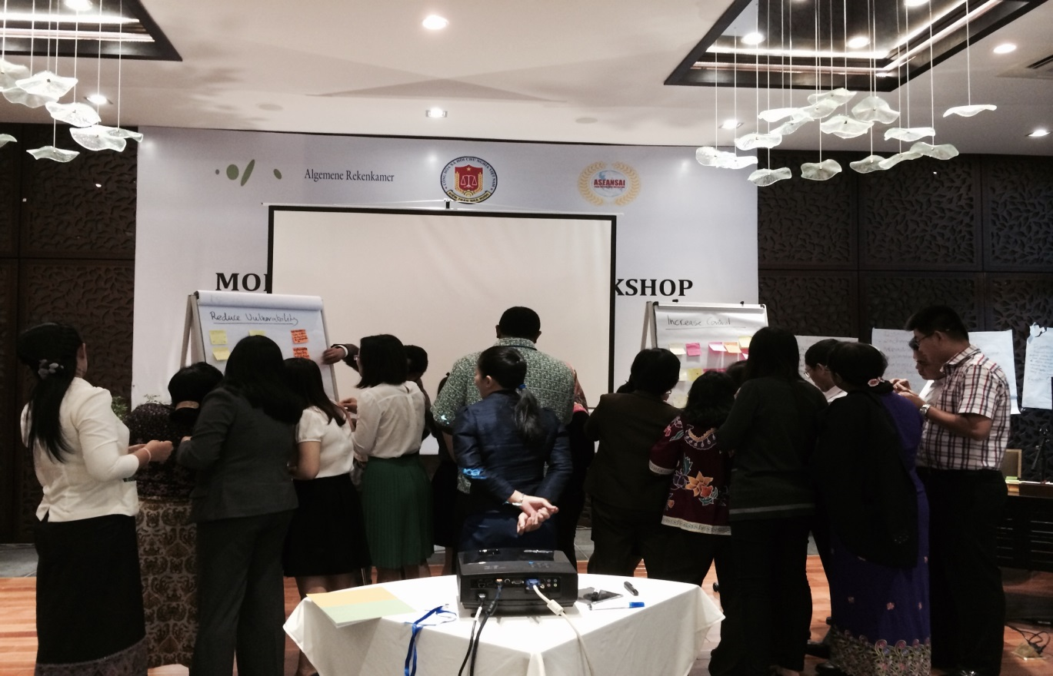

EUROSAI
Estonia
In June 2014 the IntoSAINT self-assesment took place in National Audit Office of Estonia. The assessment was facilitated by local moderators so that workshop participants would be able to express themselves as freely as possible in their own language. It was decided to focus on the processes of the entire NAOE, so besides primary processes also secondary and management processes were included. As expected, the main challenge was to translate and edit the questionnaires so that participants could uniformly understand the subject of the scores. As a result of the workshop a number of recommendations were formulated. The assessment report was presented to the Auditor General who appointed responsibilities for the implementation. The participants also found that discussions on integrity issues were most welcome and in aim to promote integrity awareness there should be such kind of discussions also in future.

Eca
In October the results of the IntoSAINT workshop were presented to the members of the European Court of Auditors (ECA). The President and the Members of the ECA thanked the facilitators of the SAIs of Norway and the Netherlands as well as the self-assessment group for their work. The recommendations are currently being followed up with the revision of the ethical framework as part of a wider reform of the ECA. To date, the provisions on whistleblowers have been improved and ethical counsellors were introduced.

Eurosai congress
The Netherlands Court of Audit was proud to host the IX EUROSAI Congress. Innovation was the central theme in The Hague from 16-19 June 2014. We shared new ideas with each other in workshops.
Also innovation on integrity was on the agenda with four workshops and a seminar.
- The EUROSAI Task Force on Audit and Ethics shared and discuss good practices of managing ethics in SAI, for example, how to implement codes of ethics, how to manage ethical dilemmas, how to enhance ethical leadership.
- The NCA explored two integrity self-assessment tools for organisations. Both tools make use of the knowledge and experiences of the organisations’ employees: we looked at IntoSAINT and how this can be used in our audit practice. The other tool is Internetspiegel, an employee perception survey that is used in the Netherlands and that allows us to benchmark organisations on various quality aspects, including integrity.
- The SAI Croatia had a workshop on VFM through the mirror of ethics within public procurement system where we discussed how SAIs can contribute to improvement and assuring public procurement procedures also in line with value for money principle and ethics.
- The State Audit Office of Hungary has for several years successfully applied an online survey and GIS application to map and visualise corruption risks of the institutions of the public sector, based on self-assessment and IntoSAINT.
- A seminar on predicting integrity incidents by assessment of organisational culture and boardroom behaviour, by the Central Bank of the Netherlands (DNB). In monitoring the financial solidity and integrity of financial institutions and the network they operate in, DNB also looks at organisational culture and behaviour. This new supervisory method is internationally recognized as an innovative and exemplary approach.
More information on the congress: http://www.eurosai2014.nl/

Seminar EUROSAI (TFAE)
On the internet a report of the seminar of the EUROSAI Task Force on Audit and
Ethics (TFAE) has been published. The seminar was prepared and hosted by the European
Court of Auditors. The aim was to raise awareness and explore possibilities of auditing ethics-related issues and including them in audit tasks, as well as address practical matters concerning such audits. Risk-mapping using IntoSAINT questionnaires was also explored. For more information:
http://www.eurosai-tfae.tcontas.pt/Articles/2013_10%20%20ECA%20Journal%20Octobre.pdf

OLACEFS
Brazil, Costa Rica and Mexico
As an experience that is becoming even more relevant to SAIs’ daily activities, IntoSAINT is taking steps forward in Latin America within the OLACEFS framework. As part of the activities considered for the roll-out of the tool, OLACEFS has launched the IntoSAINT Regional Implementation Plan, which states the general guidelines of having an IntoSAINT Workshop, including important aspects for replicating the moderators training at both the institutional and the sub-national levels.
As a result of the First Regional IntoSAINT Moderators Training held in September 2013 in Mexico City, up to date OLACEFS counts on 31 certified moderators who are able to implement IntoSAINT workshops in Latin-American SAIs. It is worth highlighting the work done by three SAIs: Mexico, Brazil and Costa Rica.
The SAI of Mexico has implemented three IntoSAINT Workshops within the institution (2012 and 2013), and it has also conducted workshops in 28 local SAIs (sub-national level). In fact, the common goal agreed by the SAI of Mexico and the 32 local SAIs at the sub-national level is for each institution to conduct at least one IntoSAINT workshop in 2014. Nowadays, Mexico has nearly 110 certified moderators who are working towards achieving this ambitious goal. Brazil has implemented IntoSAINT Workshops in three sub-regional offices during this year, also demonstrating its pledge to be part of the IntoSAINT phenomenon in the world. Costa Rica had its first IntoSAINT assessment last November.

OLACEFS Governing Board
As a result of the agreements endorsed by the OLACEFS Governing Board during its LIX meeting in May 2014, a new committee has been created: the Technical Commission on Good Governance Practices, which will be chaired by the SAI of Argentina and that has been divided in four main areas of work. One of them will be in charge of Effective Strategies of Public Integrity and Corruption Prevention, which includes the IntoSAINT implementation in the region, coordinated by the SAI of Mexico.
IntoSAINT is a tool that encourages organizational ethics, good governance and accountability in the public sector, empowering public servants in integrity terms. This way, IntoSAINT is moving forward in Latin America to help SAIs lead by example and make a difference in the worldwide fight against corruption.
Information about IntoSAINT and OLACEFS is made available via the website www.olacefs.com.

Agenda
- IntoSAINT-workshop Uruguay Feb 2015
- IntoSAINT-workshop Mexico 2015

