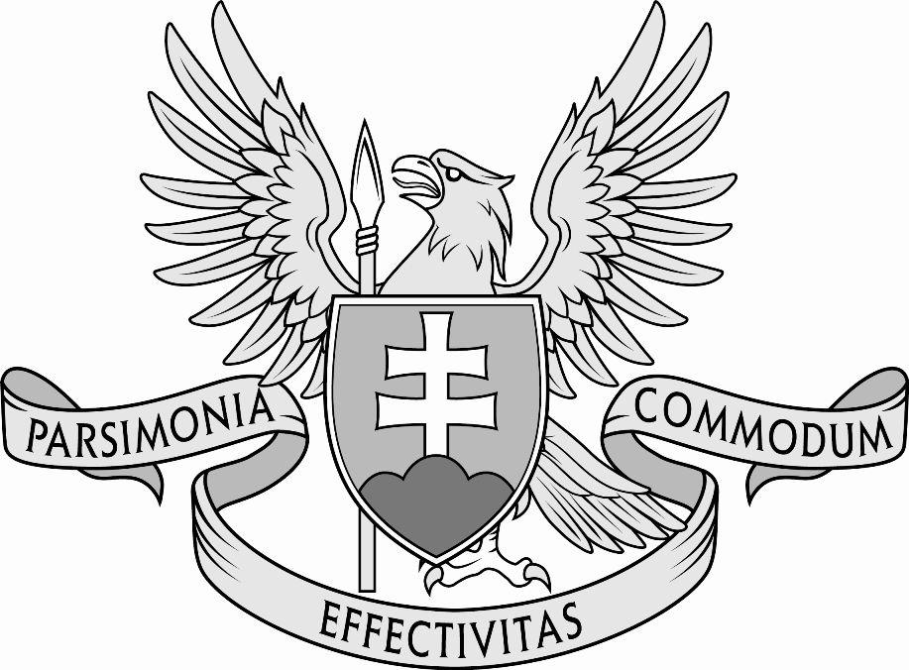

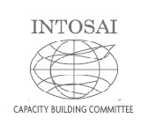

***INTOSAI Capacity Building Committee***

**Sub-Committee on Peer Review**

***Progress report***

***to CBC Steering Committee meeting 2016***

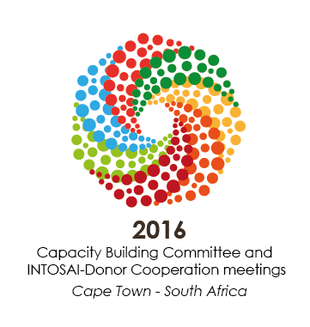

**by Supreme Audit Office of the Slovak Republic**

**I. Tasks**

The INTOSAI Strategic Plan 2011 – 2016, Goal 2 set the *Sub-Committee on Peer Review* tasks as to:

1. continue to assess and document existing peer review arrangements in the INTOSAI community;
2. continue to foster an environment where voluntary reviews are seen as beneficial to all peer reviewing and reviewed SAIs and establish mechanisms for initiating peer reviews;
3. update the CBC guidelines on peer reviews and the developed checklist on the basis of the experience of SAIs and provides further good practices on voluntary peer reviews;
4. disseminate the results of peer reviews, as appropriate and as agreed by participating SAIs.

**II. Members, cooperating organisations and partners**

**Members to date (14)**:

Austria, Bangladesh (Vice Chair), Croatia, European Court of Auditors, Estonia, Germany, Hungary, Indonesia, Morocco, Peru, Poland, Slovak Republic (Chair), Sweden, United States of America

**Cooperating organisations (1)**:

IDI

**III. *Sub-Committee* meetings**

The *Sub-Committee* meetings up to date:

* 14. June 2007, Bonn, Germany
* 27. August 2008, Bonn, Germany
* 20. – 21. May 2010, Bonn, Germany
* 08. – 09. September 2011, Vienna, Austria
* 10. – 11. September 2012, Luxembourg, Luxembourg
* 13. – 14. June 2013, Bratislava, Slovakia
* 09. – 11. September 2014, Lima, Peru
* 08. – 09. September 2015, Stockholm, Sweden

**IV. Current status**

The Supreme Audit Office of the Slovak Republic (SAO SR) is the INTOSAI CBC´s *Sub-Committee on Peer Reviews (Sub-Committee)* Chair since November 2012. It predecessor was SAI of Germany chairing *Sub-Committee* in 2005 – 2012.

*The Sub-Committee* has established the ISSAI 5600 revision Task Group (TG) that comprised representatives from SAIs of Germany, Hungary, Poland and Slovakia. The TG met several times in 2013 and 2014. Following the changes in CBC work format in 2014, the TG switched to electronic communication.

**1) Tasks a. and d.: Assess and document existing peer review arrangements and disseminate peer review results**

As of June 2016, the *Sub-Committee* was informed about 91 completed, on-going or planned peer review projects. That represented increase by 6 projects since survey 2015.

**Global e-mail survey**

To continuously manage and develop peer review documentation, the *Sub-Committee* carries out a global e-mail survey. The global e-mail survey 2016 was 4th since 2012.

**A. Peer review survey 2016 process and facts**

* The survey was undertaken in May and June 2016;
* The INTOSAI members were delivered a questionnaire via e-mail.
* In comparison to the 2015 questionnaire, there were two more questions to express preliminary interest participation at a seminar/conference to be devoted to the issues of peer review, SAI PMF and their mutual relationship.
* The survey questionnaire registered 41 replies.

**B. Peer review survey 2016 findings**

* As of July 1st, 2016, since 1999, 91 peer reviews were known to Subcommittee.
* There are 56 peer review reports and 8 memoranda at the CBC library on <http://www.intosaicbc.org/>.

|  |  |  |  |
| --- | --- | --- | --- |
| **language** | | **reports** | **MoUs** |
| **C:\Users\GAL\Pictures\flags individual countries\uk.gif** | **English** | **45** | **5** |
| **C:\Users\GAL\Pictures\flags individual countries\france.gif** | **French** | **2** | **x** |
| **C:\Users\GAL\Pictures\flags individual countries\russia.gif** | **Russian** | **1** | **x** |
| **C:\Users\GAL\Pictures\flags individual countries\germany.gif** | **German** | **3** | **2** |
| **C:\Users\GAL\Pictures\flags individual countries\spain.gif** | **Spanish** | **4** | **1** |
|  | **Dutch** | **1** | **x** |
|  | **total** | **56** | **8** |

* The largest number of peer reviews was conducted in 2014 – seventeen.
* The second year in numbers was 2012 when sixteen peer reviews were recorded.
* No peer reviews were registered in the year 2002 and 2003.

**54 SAIs (28 % of INTOSAI members) as reviewers were involved in projects 1999 – 2015.**

|  |  |
| --- | --- |
| **SAI** | **as peer reviewer** |
| Netherlands | 23 |
| Sweden | 22 |
| Norway | 20 |
| United Kingdom | 16 |
| Denmark | 11 |
| ECA, Germany | 9 |
| Canada | 8 |
| Australia, France, RSA | 7 |
| Austria, Peru | 6 |
| Poland, USA, Chile | 5 |
| Finland | 4 |
| New Zealand, India, Portugal | 3 |
| Switzerland, Slovenia, Zimbabwe, Tanzania, Uganda, Guam, Brazil | 2 |
| Belgium, Puerto Rico, Costa Rica, Spain, Estonia, Latvia, Kenya, Zimbabwe, Portugal, Lithuania, Malawi, Viet Nam, Russia, Rwanda, Bahamas, Honduras, Morocco, Kosrae, Namibia, American Samoa, Slovakia, Eritrea, Ireland, Luxembourg, Mexico, Scotland | 1 |

**The peer reviewers’ engagement in all peer review projects since 1999 by INTOSAI regions**

**Peer reviews performed by year**

**Other facts:**

* In period 1999 – 2015 there were 5.4 peer reviews on average per year.
* A peer reviewing team was composed from 3 SAIs.
* Average number of auditors from reviewed SAI directly involved in the peer review: 12;
* Average number of auditors from reviewing SAIs directly involved in the peer review: 6.
* Average number of days spent by the peer reviewing team at the peer reviewed SAI premises: 14 days;
* Topics and scope of the peer review varied widely according to the peer review goal.
* Recommendations ranged from few to several dozen;
* Follow-ups by the peer reviewing team were seldom;
* ISSAI 5600 and Checklist were used primarily for constructing MoU, planning and selection of the questions used for peer review.

**Survey conclusions**

The survey participants took a peer review as opportunity to:

* confirm good work done by the reviewed SAI;
* uncover gaps in the reviewed SAI activities;
* source and get ideas for continuous improvement in the given SAI audit activities and help to build the SAIs as modern institutions;
* benefit participants in form of information, knowledge and experience exchange.

**2) Task b.: Foster environment where voluntary peer reviews are seen as beneficial**

* In order to promote voluntary peer review concept and general knowledge about it, the *Sub-Committee* informed the INTOSAI community members and other interested parties on the progress made in the *Sub-Committee* work on the ISSAI 5600 revision, e-mail survey results and other peer review related topics on selected internet pages:

[www.intosaijournal.org](http://www.intosaijournal.org/)

[www.intosaicbc.org](http://www.intosaicbc.org/)

[www.eurosai.org](http://www.eurosai.org)

[www.issai.org](http://www.issai.org/)

* SAO SR, SAI of Norway and INTOSAI General Secretariat (INTOSAI GS) signed a trilateral MoU in May and June 2016 to perform a review of the Global peer review on independence being conducted by the SAI of Austria, INTOSAI GS and other auditors from 7 relevant participating INTOSAI regions. Results are expected in 2017.

**3) Task c.: Update the peer review guidelines and provide best practice examples**

In 2010, the XX INCOSAI endorsed the Peer Review Guide with Checklist as ISSAI 5600. The Guide was translated into all INTOSAI official languages and some other working versions were made (in Bengali, Hungarian, Mandarin, Portuguese, and Slovak).

*T*he *Sub-Committee* has decided to present a revised ISSAI 5600 to the XXII INCOSAI in 2016 that would reflect the issue of peer review development and experience gathered in the INTOSAI community since endorsement.

The Checklist was renamed as Peer Review Areas and Questions (PRAQ) that offer inspiration to the peer review parties. PRAQ is an annex to the ISSAI 5600.

ISSAI 5600 underwent complete reconstruction. The draft was reworked several times and it was a subject to extended exposure period for four and half months. The exposure draft at [www.issai.org](http://www.issai.org) registered 30 SAIs/institutions providing 138 comments and 98 suggestions were accepted and 40 were noted. The endorsement draft is deemed by the *Sub-Committee* practical, reader friendly with clear and easy follow structure (below):

|  |  |  |  |
| --- | --- | --- | --- |
| **chapter** | **present ISSAI 5600** | **chapter** | **revised ISSAI 5600** |
| **preface** | **preface** |  | **X** |
| **1** | **Introduction** | **1** | **Introduction** |
| **2** | **Definition** | **2** | **Definition** |
| **3** | **Initial consideration** | **3** | **Strategic consideration** |
| **4** | **Peer review agreement (MoU)** | **4** | **Partners and resources** |
| **5** | **Preparation and conduct** | **5** | **Memorandum**  **of Understanding** |
| **6** | **Follow-up and Evaluation** | **6** | **Planning** |
|  |  | **7** | **Field work** |
|  |  | **8** | **Reporting** |
|  |  | **9** | **Implementation**  **of results**  **and follow-up** |
|  | **glossary**  **of terms** |  | **X** |
| **pages** | **46** |  | **Guide - 29**  **PRAQ - 27** |

**V. The conclusions, recommendations and future tasks**

The Sub - Committee:

1. Have finished 3-year work on ISSAI 5600 revision according to the Due Process for INTOSAI professional standards;
2. Proposes to the CBC Steering Committee the ISSAI 5600 and its Annex PRAQ for endorsement at the XXII INCOSAI 2016;
3. **In the period 2017 – 2022**, will continue to develop and update the existing peer review documentation through global peer review surveys;
4. **In the period 2017 – 2022**, will further develop the PRAQ document to widen the scope of possible peer review areas;
5. **In the period 2017 – 2022,** will continue to promote peer review as a tool for quality assurance and capacity building within the INTOSAI community and external professional environment through articles in electronic media in cooperation with INTOSAI Regional Organizations and other INTOSAI bodies;
6. **In 2017** [in the line of the INTOSAI Strategic plan 2017 – 2022, Strategic objectives for Goal 2 (Capacity Development) and Goal 3 (Knowledge Sharing and Knowledge Services) and Crosscutting priority 3 (Ensuring effective development and coordination among standards-setting, capacity development, and knowledge sharing to support SAIs and improve their performance and effectiveness)] will conduct a global survey among INTOSAI members followed by a study on topic **Peer review as method to apply INTOSAI assessment tools.** Selected INTOSAI bodies and possible external partners will be approached to join the project.
7. **In 2017**, will support and perform a review of the *Global peer review on independence* project conducted by INTOSAI General Secretariat [see point 2) Task b, second bullet point].
8. Based on the results of the survey and study made (see point 6 above) will propose to the INTOSAI community to hold a global conference **in spring 2018** topic being **Peer review as method to apply INTOSAI assessment tools** (providing adequate interest would be shown by the professional community at the time).
9. **In 2019**, will publish the results of the global survey, study and global conference addressing the issues raised by the mentioned events and documents in a comprehensive material summing up the knowledge collected.