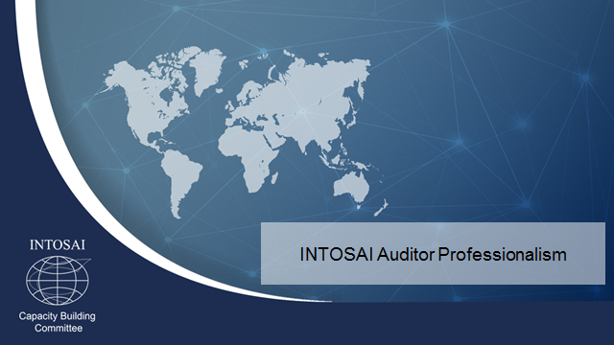

TASK FORCE ON INTOSAI AUDITOR PROFESSIONALIZATION

STRATEGIC CONCEPT
2017-2019

- BACKGROUND

The past number of years in INTOSAI have been characterised by an extensive emerging debate on professionalism. During early December 2017, Auditors-General from around the globe met in Abu Dhabi for INCOSAI 2016, where one of the key discussion topics focused on strengthening of professionalism in INTOSAI.

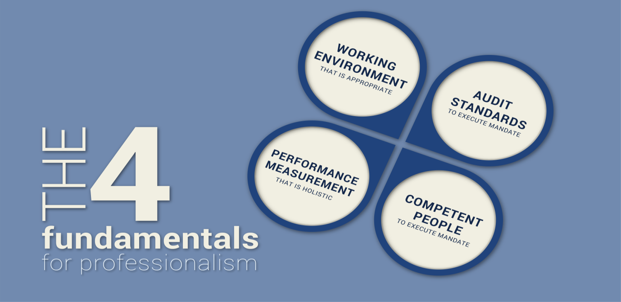

In keeping with this, the INTOSAI Capacity Building Committee (CBC) presented the congress with a position paper called “The enabling mechanisms to facilitate and structure professional development at SAI level” (referred to in the rest of the documents as the enabling mechanisms document) as a key driver of many of its deliverables. It also served as a key input to the theme paper and discussions in respect of INCOSAI 2016’s Theme 2 on the professionalization agenda for INTOSAI.

The document aims to define the concept of professionalism in INTOSAI and provide a basic roadmap of developments required to fully empower INTOSAI regional organisations and individual SAIs to deal with this professionalization concept, in the context of the CBC’s mandate and strategic objectives. The document also quite clearly indicates its intention to deal with professional development in the broadest possible definition, moving away from the very narrow scope of work taken on by the INTOSAI CBC in 2014. The term “certification” - that was originally used - was rather limiting, with many SAIs arguing against the need for that specific type of development / assessment. However, all SAIs subscribed to the need for competent staff to give effect to their mandates, which prompted the “broadening” of the subject matter to professional development.

The document furthermore introduces the phrase “global profession, local solution” to clearly position the work of the CBC at a global level. In keeping with this catchphrase, it also deals with INTOSAI’s ambitions to develop professional pronouncements on auditor competence and to establish enabling relationships with a number of key international bodies in the world of accounting and auditing, human resources, etc.

Some of the documents specifically referenced in the “enabling mechanisms” document were considered and approved at INCOSAI. The most pertinent of these are:

- The “SAI Performance Measurement Framework” – a framework intended, amongst others, as an assessment tool against the definition of professionalism, to define capacity development needs (SAIs in developing environments) or to confirm the status of a “member in good standing” (SAIs in developed environments),

- The “Framework for Regional Professionalism” – a framework that challenges the regional structures within INTOSAI to review and structure their service offerings in very much the same way that Professional Accounting Organisations (PAOs) would do, and

- An initial “Competency Framework for Public Sector Audit Professionals” (referred to as the INTOSAI competency framework in the rest of the document) – an attempt to define the unique competencies for public sector external auditing in relation to the International Standards of Supreme Audit Institutions (ISSAIs) and intended as a way to make the discussion around auditor professionalism a more tangible one.

In concluding on these developments, INCOSAI resolved, amongst others, to establish a new a new structure – the “Task Force on INTOSAI auditor professionalization (TFIAP)”, chaired by the CBC with the aim to:

- Continue to research enabling mechanisms required to facilitate and structure professional development in INTOSAI, including cooperating with relevant INTOSAI organs and INTOSAI related entities in order to forge appropriate relationships – based on confirmed criteria – with the broader international accounting and auditing community on work relating to auditor education, training and capacity development,

- Utilise the competency framework for public sector audit professionals as a basis for further discussion and refinement of the concepts related to professional development in order for INTOSAI to be provided with a set of professional pronouncements on auditor competence in the next three to six years, including the development of specific professional development options based on the competency framework, including auditor certification, and

- Consult, through the CBC, with the new Forum for INTOSAI Professional Pronouncements (FIPP) regarding the structure and process for developing professional pronouncements on public sector auditor competence in order that standards and guidance on auditor competence can be developed successfully.

This document aims to provide a strategic overview of the work of this Task Force - which will deal with the requirement of “having competent people” in the definition of professionalism over the next three years.

- MEMBERSHIP AND TERMS OF REFERENCE

The following permanent membership is envisioned for the TFIAP:
- CBC Secretariat representative (Chair) and two to three members (representative of all audit systems),
- Other Goal Chair representatives (at least one member each from the Professional Standards Committee (PSC), the Knowledge Sharing Committee (KSC), and Policy, Finance and Administration Committee (PFAC)),
- Specific representatives from the three PSC sub-committees that deal with the three streams of auditing (financial audit, compliance audit and performance audit),
- INTOSAI Regional Organisation representatives (at least four – given past proven expertise in professionalization),
- INTOSAI Chair representative,
- General Secretariat representative,
- INTOSAI Development Initiative (IDI) (two persons - one at executive level and one technical expert),
- INTOSAI-Donor Steering Committee representative, and
- Forum for INTOSAI Professional Pronouncements (FIPP) liaison officers (as determined by the FIPP leadership).
Observers
(it will be essential for the TGIAP to have access to the best possible global expertise in the area of professionalization, as well as practical experience of Supreme Audit Institutions that have been active in this space):
- International Accounting Education Standards Board (IAESB)
- IFAC (with emphasis on their work on professionalization and the development of Professional Accounting Organisations (PAOs),
- Professional bodies (such as IIA / CIPFA / ATD),
- HR specialist (to be confirmed)), and
- Representatives from SAIs that have been active in this space.

The TFIAP will provide the following reports:
- Updates to the CBC leadership on at least a quarterly basis,
- Annual reports to the CBC Steering Committee, and
- Annual reports to the INTOSAI Governing Board.

The relationship with the FIPP will be managed through the liaison officers that the FIPP leadership has allocated to the task team. Cognisance is taken of the Strategic Development Plan for the INTOSAI Framework of Professional Pronouncements (SDP) and the related due process requirements in determining the exact parameters of the working relationship with the FIPP. The classification of the work around professional pronouncements for auditor competence as priority 3 in the SDP (therefor work that FIPP only intends dealing with at a detailed level post 2019) is of particular relevance in structuring the work of the TFIAP, It allows for a minimum period of three years to engage with the INTOSAI community on the exact need for these type of professional pronouncements.

The TFIAP intends meeting at least once year, in a contact session, separate from the progress evaluation meeting at the time of the annual CBC meeting. Additional sessions (such a project meetings, engagement with external stakeholder / advisory capacities) will, where possible, be handled via e-mail, teleconferences and video-conferences. Should contact sessions be required, these will be coordinated in a way to dovetail with the existing INTOSAI meeting schedule.

- BROAD ROADMAP FOR WORK

In broad terms, the provisional roadmap for the next three years until INCOSAI 2019, can be depicted as follows:

2016 | “Competency Framework for Public Sector Audit Professionals” (2016)  “The enabling mechanisms to facilitate and structure professional development at SAI level” (2015)  INCOSAI 2016
2017 | Establishment of the Task Force on INTOSAI Auditor Professionalization / debriefing key stakeholders on the outcomes of INCOSAI 2016  Second project:  Further refinement, development and consultation relating to the 2016 “Competency Framework for Public Sector Audit Professionals”. This may include dealing with competency requirements beyond just public sector auditing (such as accounting, leadership, subject matter expertise, etc).  Third project:  Dealing with the competency requirements of SAIs with jurisdictional powers and other possible scenarios not yet catered for.  Fourth project:  Development of practical guidance to support specific process steps identified in the “Process Flow for Professional Development Initiatives” (such as competency-based human resource practices).  First project:  (a) Continue with the research embarked upon the first “enabling mechanisms document, focusing on unpacking the parameters of the need for professional pronouncements on auditor competence with a view to producing a position paper that drive the development of these pronouncements post-2019; Identify existing pronouncements on auditor competence that can serve as a departure point for the INTOSAI-specific development process;  (b) Compile a compendium of professionalization case studies; and  (c) Initiate a discussion on the “auditor of the future  All three initiatives will be based on a “Process Flow for Professional Development Initiatives” (to be confirmed during the first TFIAP meeting)
2018
2019 | Engagement with FIPP on post-2019 development process  INCOSAI 2019
Development of INTOSAI Professional Pronouncements on auditor competence – post-2019

The first project represents a continuation of the research and work contained in the original enabling mechanisms document. Initially this project will focus on unpacking and understanding the needs for professional pronouncements (at the level of standards and guidance) on auditor competence, taking into account the widest possible range of views within the INTOSAI community. Instead of doing this through a top-down, very academic process to determine or survey the needs of the INTOSAI community, it is proposed that a very basic (draft) “Process Flow for Professional Development Initiatives” (PFPDI) be confirmed during the first TFIAP meeting, to drive this process.

This draft framework will initially aim to document the basic process steps that any SAI should consider in developing a professional development initiative (anything from a very basic certification course to the introduction of a professional qualification option), but – over time – be enhanced with the results of further research, consideration of practical experiences by SAIs, etc to a point where a) it can be confirmed as a very detailed and well-consulted guide on the topic (around 2019) and b) where it can serve as the basis of a very informed and inclusive, bottom-up exercise to determine the ‘universally true” principles in this process of professional development that should be considered at the level of professional pronouncements.

The intention with this process is to develop a position paper that will deal with the actual detailed drafting of such pronouncements beyond 2019 – the time period that FIPP has set aside in its SDP for the consideration of pronouncements of auditor competence.

As part of the work on the envisaged position paper, research should properly reflect on the availability of existing professional pronouncements that can serve as a possible departure point for and/or inform the crafting of INTOSAI-specific pronouncements on auditor competence.

In keeping with the intention to work towards a decision on professional pronouncements on auditor competence, using an inclusive, bottom-up process (as described above), the TFIAP intends creating a work-space on the CBC web-site to compile a compendium of professionalization case studies that can both inform the development of professional pronouncements and can serve as valuable inputs / lessons learnt into regional or even SAI processes of professionalization. The PFPDI process steps can serve as an easy way to give structure to these submissions to ensure a level of consistency / user-friendly use of these case studies.

In similar vein, the TFIAP will also create a work-space on the CBC web-site to initiate a discussion on the “auditor of the future” – work that, over time, will translate in to the updating of pronouncements on auditor competence and related competency frameworks. This builds on the work done during 2015 during the Global Audit Leadership Forum (GALF), hosted by SAI New Zealand and subsequent requests (such as the 2017 Commonwealth Auditors-General Conference in Delhi).

The second project deals with the next phase of refinement of the INTOSAI competency framework and recognises the need for further refinement of this global framework, including broader consultation and testing in certification programs offered by the IDI, INTOSAI regional organisations, SAIs and learning providers. Consideration should also be given to dealing with other focus areas beyond just the current public sector auditing focus (such as accounting, leadership, etc), which may align well with research work (flagged in the first project) on existing professional pronouncement on auditor competence.

To be able to provide INCOSAI 2019 with a single position paper on professional pronouncements on auditor competence, which will need to deal with, amongst others, competency requirements, it is accepted that this project will have to feed into the first project at the start of 2019.

The third project is proposed based on commentary received during the first (2016) consultation process on the INTOSAI competency framework that indicated the need to consider the applicability of this framework to SAIs with jurisdictional powers and that suggested the need for specific guidance in this regard. It is proposed that this project runs concurrently to the second project, headed up by a prominent SAI with jurisdictional powers, with representation from Europe, West-Africa and South-America, closely supported by the TFIAP secretariat.

In confirming the PFPDI (see project 1) the task-force envisages that it may be necessary to confirm projects to develop guidance to back up certain of the process steps listed in the PFPDI (especially those where the strategy of “lifting” guidance from SAI case studies may not address needs quick enough) This will be done in line with the needs expressed by the various INTOSAI regional organisations and/or other users - noted as a possible fourth project. Given initial regional feedback, it is proposed that this project may initially focus on confirming a partnership with an INTOSAI regional organisation to develop guidance on competency-based human resource practices, although it is accepted that resource requirements may cause this to be held over for the post-2019 period.

Throughout these projects the involvement of public sector auditors (in financial -, compliance – and performance auditing), as in previous years, is accepted as a baseline requirement. At the same time the involvement of human resource (and where relevant / possible organisational development) experts from SAIs is quite critical.

- PROPOSED ACTION ANALYSIS

At a more detailed level, an initial work-plan for the period 2017 to 2019 is set out below:

Year | Quarter | Proposed action
2017 | Q1 | - Update the CBC web-site with the outcomes of INCOSAI 2016, related to the old TGIAC / new TFIAP,  - Compile a draft strategic concept for the TFIAP for consideration by the CBC leadership and, later, the first meeting of the task-force,  - Invite members to the new TFIAP, using the new draft strategic concept,  - Where not already covered in steps 1 to 3, debrief key stakeholder regarding the outcomes of INCOSAI 2016, related to the old TGIAC and the establishment of the new TFIAP (emphasis on stakeholders external to the INTOSAI community, and  - Confirm a work-method with FIPP (with the priority focus on creating liaison officers between the FIPP and the TFIAP).

Year | Quarter | Proposed action
2017 | Q2 | - Prepare for the first meeting of the task-force in early June 2017, with emphasis on  - Discussing and confirming the proposed draft TFIAP strategic concept,  - Work-shopping the needs for professional pronouncements on auditor competence at hand of the development of a draft “Process Flow for Professional Development Initiatives” (PFPDI),  - Work-shopping the parameters of possible further refinements to the current INTOSAI competency framework,  - Contact SAIs with jurisdictional responsibilities, in consultation with the SAI of France (as chair of the AISCCUF), to test the viability of establishing the third project to deal with competency requirements in these SAIs,  - Facilitate the agenda for the first meeting of the TFIAP,  - Communicate the outcomes of the first TGIAP meeting to all stakeholders, and  - Update the TFIAP section of the CBC web-site.

Year | Quarter | Proposed action
2017 | Q3 | - Finalise the draft PFPDI that will provide the structure for the work of project one,  - Agree with CBC secretariat to make a dedicated space available on the CBC web-site for the submission of case studies on SAI professionalization (based on parameters of discussions during first TGIAP session) and conduct further research to identify existing professional pronouncements that inform the work of the first project,  - Establish a small work-group (within the CBC) to give structure to the efforts of project two and agree a specific work-plan,  - Establish the third project, dealing with competencies for SAIs with jurisdictional responsibilities, depending on feedback from affected SAIs from previous quarter and willingness to from key players to take on this responsibility,  - Explore the option of an INTOSAI regional organisation to take on the project to draft the guidance envisaged in the fourth project and confirm the parameters of this project.  - Report back on progress made with the work of the TGIAP during the annual CBC meeting,  - Update the TFIAP section of the CBC web-site (case studies, commentary of auditor of the future and progress updates).

Year | Quarter | Proposed action
2017 | Q4 | - Continue with the submission of case studies / further research to identify existing professional pronouncements that inform the work of the first project,  - Continue with the work on the second project (consultation and further refinement),  - Monitor the work of the third and fourth projects, and  - Update the TFIAP section of the CBC web-site (case studies.
2018 | Q1 | - Continue with the submission of case studies / further research to identify existing professional pronouncements that inform the work of the first project,  - Conclude initial consultation phase on the INTOSAI competency framework and process inputs,  - Monitor the work of the third and fourth projects,  - Plan for the next full TFIAP meeting in Q2 of 2018 (potentially at the NAO, United Kingdom), and  - Update the TFIAP section of the CBC web-site (case studies and progress update).
2018 | Q2 | - Continue with the submission of case studies / further research to identify existing professional pronouncements that inform the work of the first project,  - Present a first draft of the reworked INTOSAI competency framework(s) to the third meeting of the TFIAP,  - Monitor the work of the third and fourth projects, and  - Update the TFIAP section of the CBC web-site (case studies and progress update).

Year | Quarter | Proposed action
2018 | Q3 | - Conduct further work on position paper and INTOSAI competency framework(s) as agreed in the third TFIAP meeting,  - Consider arranging a work-session of the third and fourth projects as a fourth TFIAP meeting during the annual CBC meeting with a view to consider first draft deliverables and to agree on process to finalise,  - Report back on progress made with the work of the TGIAP during the annual CBC meeting, and  - Update the TFIAP section of the CBC web-site (case studies and progress update).
2018 | Q4 | - Prepare a first draft of the position paper to drive the development of professional pronouncements on auditor competence post 2019,  - Conduct work to finalise deliverables from third and fourth projects, and  - Agree on parameters of further work required / consultation on the deliverables from all four projects with the CBC leadership,  - Plan for the 2019 TFIAP meeting, and  - Update the TFIAP section of the CBC web-site (case studies and progress update).
2019 | Q1 | - Present deliverables from all four projects to an early fifth meeting of the TFIAP, with a view to confirm these as ready for final consultation in the INTOSAI community (3 months), and  - Update the TFIAP section of the CBC web-site (case studies and progress update),

Year | Quarter | Proposed action
2019 | Q2 | - Rework deliverables from all four projects, based on commenting period for final consideration at the annual CBC meeting, and  - Update the TFIAP section of the CBC web-site (case studies and progress update),
2019 | Q3 | - Consider final deliverables from all four projects at the annual CBC meeting,  - Prepare material (video’s banners, publications) for use at INCOSAI,  - Prepare work-plan of TGIAP for post 2019, and  - Update the TFIAP section of the CBC web-site (case studies and progress update).
2019 | Q4 | - Present final deliverables to the INTOSAI Governing Board for approval and to the INCOSAI for adoption.

- CONCLUDING COMMENTS
INCOSAI 2016 has entrusted the TFIAP with the responsibility and privilege to coordinate work on auditor competence over the next three years. During the congress is was very clear that, as part of the theme on professionalization, all Supreme Audit Institutions (SAIs) recognise and value the need for competent people to handle the critical mandate that SAIs carry out on behalf of the people of the country they function in.
It was also very clear in the discussions, in the formal congress proceedings and during the networking opportunities created, that many SAIs has invested heavily in the task of professionalization of their people. This document aims to tap into this wealth of knowledge and experience, to give structure to the process of professionalization of SAI staff thought the development of INTOSAI professional pronouncements for auditor competence.
Through the contribution of SAI’s and INTOSAI regional organisations sharing their experiences, challenges and ambition regarding the development of auditor competence, supported by the expertise of the different strategic goal committees, working groups, sub-committees and task forces, as well bodies such as the IDI, the journey to develop professional pronouncements for auditor competence, can just be a rewarding and constructive one. In keeping with the motto of the INTOSAI Capacity Building Committee’s presentations at INCOSAI 2016, it is through valuing and formalising local solutions, that we can build strong and relevant global profession.
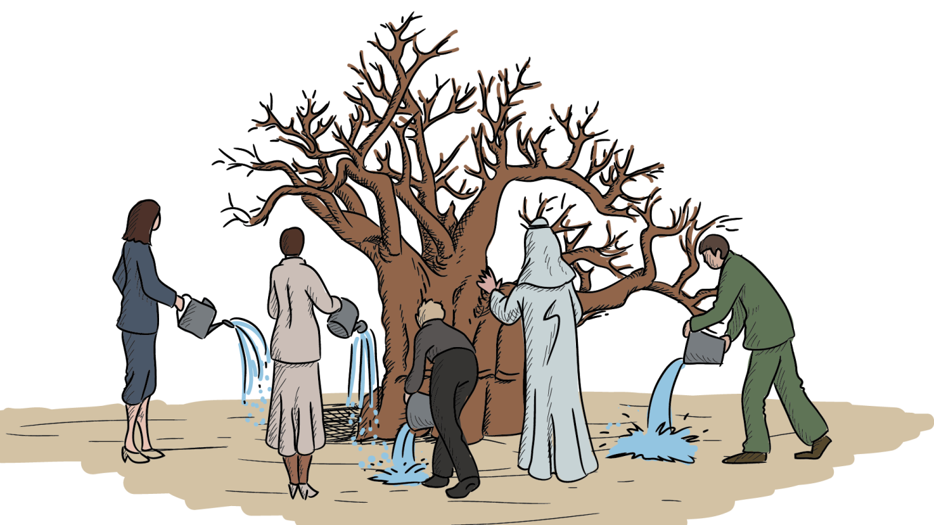
“GLOBAL PROFESSION, LOCAL SOLUTION”

Perhaps linked to the INTOSAI PSC meeting in Brazil in June 2017.
This step will require the development of a stakeholder plan to ensure the active population of the framework by relevant players.
Terms of reference for this group, as well as more specific milestones will be determined once the need has been confirmed. Accordingly, these details have not been added to this action analysis.

