Hackathon, an effective tool for SAI to communicate with its environment

Who in the SAI community has ever heard of the term “Hackathon”? For us, the first time was last year during the preparation of the 50th anniversary of our SAI festivities. The Tunisian Court of Accounts (CoA) was established in the Tunisian Constitution of June 1959 and organized by the law of March 8, 1968. Its 50th anniversary was celebrated on March 8, 2018 with an international workshop on «The role of SAIs in promoting good governance». During the preparation of this event, the SAI’s partners, especially the World Bank (WB), proposed the organization of a Hackathon for the Court… One year later the Hackathon was launched in Tunis on March 8, 2019.
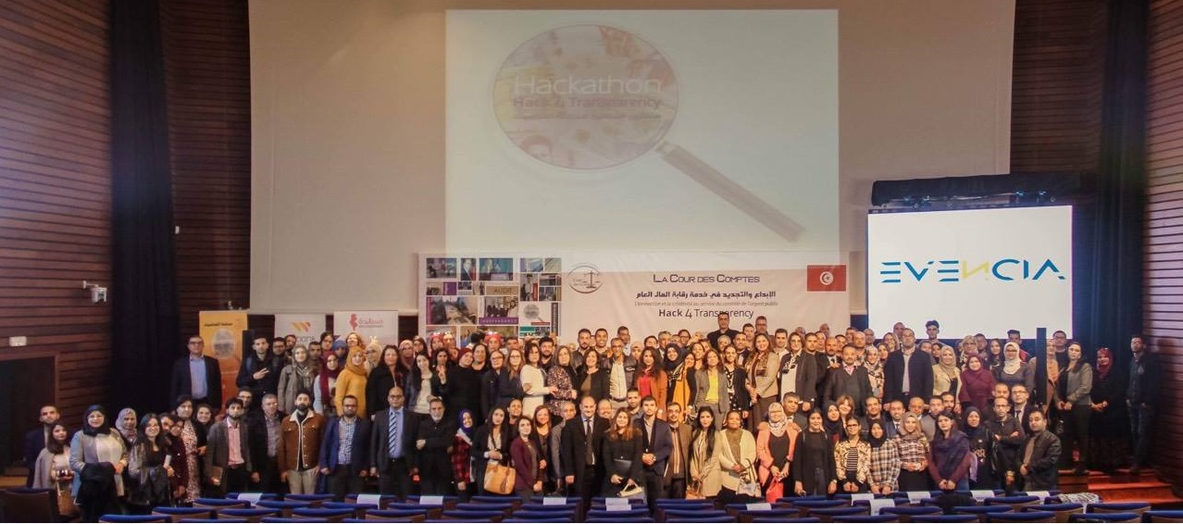
Group photo, Tunis the 8th March 2019, launching event of the Hackathon
But the story started before this date. Between March 2018 and March 2019, a team from the World Bank kept working seriously on the project. A concept note was discussed by the CoA’s communication committee. In this note, the proposal was to hold two Hackathons in two different cities, followed by a final one in the capital Tunis. However, we defended the idea to hold five regional Hackathons in the cities where regional offices of the Court are located, followed by a final one. Our partners from the World Bank accepted the challenge to hold this huge event.
In early 2019 a workshop was held gathering magistrates from the CoA with the Communication Committee and World Bank representatives, to consider the challenges for our SAI related to its working processes and its environment. After this workshop, the overall topic of our Hackathon was determined to be “TRANSPARENCY”, and the name that followed was “Hack4Transparency”.
Five main challenges were chosen:
Challenge 1: Audit process: optimization / effectiveness,
Challenge 2: Data gathering, processing and exploitation: optimization / effectiveness,
Challenge 3: External environment: Interaction / two-way communication,
Challenge 4: Reports: Simplification and vulgarization,
Challenge 5: Follow-up of the CoA observations and recommendations: strengthened mechanisms.

During that time, we began to understand what “Hackathon” stands for. It is a combination between two words “Hacker” and “Marathon”. It is an IT competition in which participants during a limited time (usually 24H or 48H) develop innovative solutions to face some challenges fixed and announced on beforehand. A team is composed of 3 to 6 participants that work together on one idea/project and aim to convince the jury that they have the best project – to win the prize.
Up until this time all seemed perfect. We fixed the agenda, milestones, contacted the offices in the cities where regional Hackathons would take place, profiles of participants, partners…
Still, we were not sure about the results. In our minds, many questions were raised. And like wise auditors we were wondering: will there be enough motivated participants and partners involved? How do we motivate people to be part of this adventure? What will be the impact of the Hackathon? A better visibility of our SAI maybe. What are the risks of this experience? Maybe it will be harmful for the image of our institution…
For one month at least, we were running in the process of preparation for the first Hackathon which was decided to be held in Sfax, the city where the second regional chamber of the CoA was established in 2004. This process consisted of meeting with participants, establishing relationships with universities, administrations and interested actors and media. We had to attract the best participants, mentors, jury members etc. and motivate all of them for the event.
Hack4Transparency of Sfax was held in the premises of the Digital Research Center of Sfax (CRNS) from 15 to 17 March 2019 with 50 participants, 8 mentors, 9 members of jury, many people involved in the organization, 10 ideas, 48 hours of nonstop work. The output was 10 IT-projects developed by the 10 teams each composed of 5 participants with various backgrounds (IT, economy, law, finance, management, medicine, administration…) all enthusiastic to be the winners and to reach the final competition to be held in June 2019.
During the 48 hours of hacking, many good practices, feelings, competencies and knowledge were shared between participants, mentors and the organization team. Three Flash conferences were organized for the participants about: monetizing a web-product, web marketing and pitching skills.
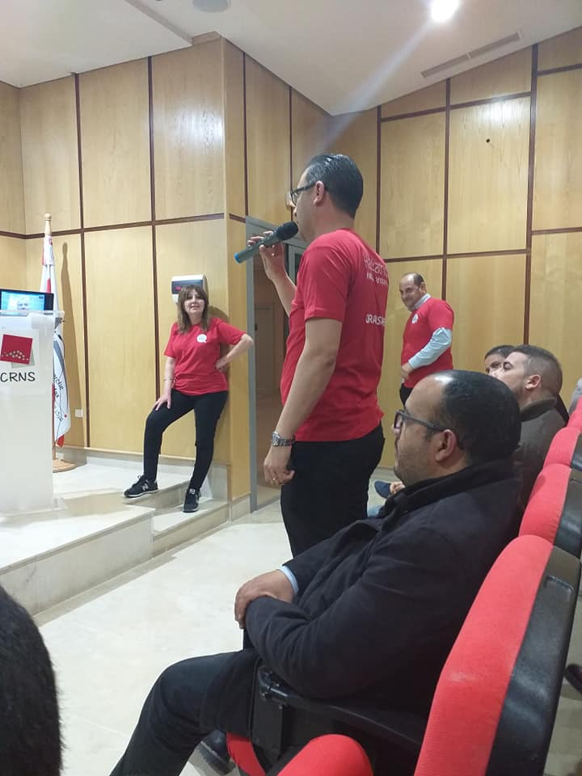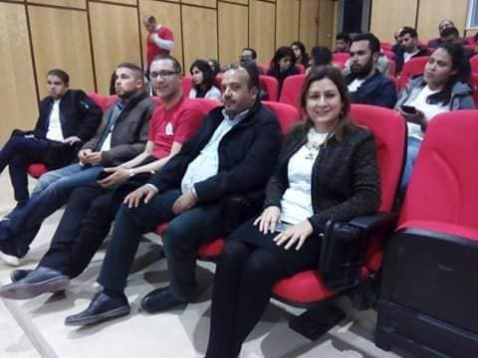
Photo of Hackers, mentors and organizers in the first Flash Conference, Sfax 15th March 2019.
At the end of the 48 hours, and before announcing the 3 winners in the closing speech, the President of the jury said: -“Thanks to the Hackathon and to the participants and their innovative ideas, we believe that we are realizing a dream of many generations of magistrates, clerks and administrative staff of CoA: The dream of being a model organization adding value to the lives of citizens.”
A participant expressed the impact of Hack4Transparency in simple words: -“Before the Hackathon, when I saw or listened to media speaking about the Court of Accounts I changed to another channel - but after the Hackathon, I listen carefully to all discussions related to the CoA. Surrounded by my family members, I try to explain to them what I have learned during the Hackathon event.”
The 10 projects all had confirmed scalability and big potential to add value to the CoA’s auditing process, to its work and to its image in general. Some of them could be a good beginning to set up startups. The 10 projects can be presented as follows:
Team 1: Ma Commune (My Municipality): A mobile application that allows users (parliamentarians, Government members, citizens, civil society…) to access to main financial indicators of all municipalities in Tunisia. This application also enables the CoA to identify high risk areas and therefore audit missions can be programmed.
Team 2: THE EYE: Web and mobile applications that facilitate the follow-up of the CoA audit missions’ progress in real time according to 5 steps. These applications enable users (citizens, members of CoA, parliamentarians, Government members, administrations, etc.) to send their complaints and proposals (text and attached files in any format) to the CoA about any audit mission during the first two phases (diagnosis and field work). The complaints and/or proposals will reach the head of the chosen audit mission.
Team 3: تثمين (Adding Value) : A platform that makes possible to develop financial diagnosis of Public Administrative Entities (EPA), municipalities and governorates that uses financial data of these entities available on national applications and databases. This platform is an alternative of painful archives processing and that can maximize the number of annual audits for the CoA with saving of time, efforts and resources.
Team 4: Elections+: An application that allows a real-time monitoring of the elections accounts processing from the deposit of these accounts at the CoA’s offices until the result. It permits to ensure a better transparency vis-à-vis members of legislative or local elections candidate lists, presidential candidates, associations and citizens.
Team 5: Fahamni (Explain to me): A platform of videos, images, graphs or other tools that aims to simplify the content of audit reports published by the CoA. These reports are characterized by an increased technicality. The platform aims to improve the access rate to the content of these reports and to facilitate its understanding by all interested users. The interaction with users will be ensured via a chatbot.
Team 6:حاسب (Accountability): An application that allows users (citizens, civil society, etc.) to access to the financial data of the entities under control of the CoA in a simplified way. The user can also send comments and complaints to the CoA.
Team 7: Smart Magazine : An electronic magazine downloadable on computers and smart phones that aims to present the CoA, its attributions and its reports to the maximum of the citizens by using the electronic marketing techniques. In addition to that, it aims to receive complaints from citizens using the QR Code. Likewise, the application allows all its users to receive all news about the CoA, its partners and related subjects.
Team 8: AKRALI (Read to me): A website for citizens to help them understand the content of the municipal financial audit reports produced by the CoA and an Android application that translates this content in audio format to cover more recipients and even the visually impaired.
Team 9: عينك على فلوسك(Keep an eye on your money): An interactive platform under the supervision of the CoA which aims to involve the citizen in the programming CoA audit missions, the monitoring of missions in progress and the follow-up of published reports.
Team 10: Better Data Management BDM: A web platform that allows the CoA to progress in terms of Open Data from one star to 5 stars on the scale of Tim Berners-Lee. With this application, the user can access to a data specific link on the website of the CoA to combine statistical indicators, as needed, which will be calculated from many databases shared by the CoA.

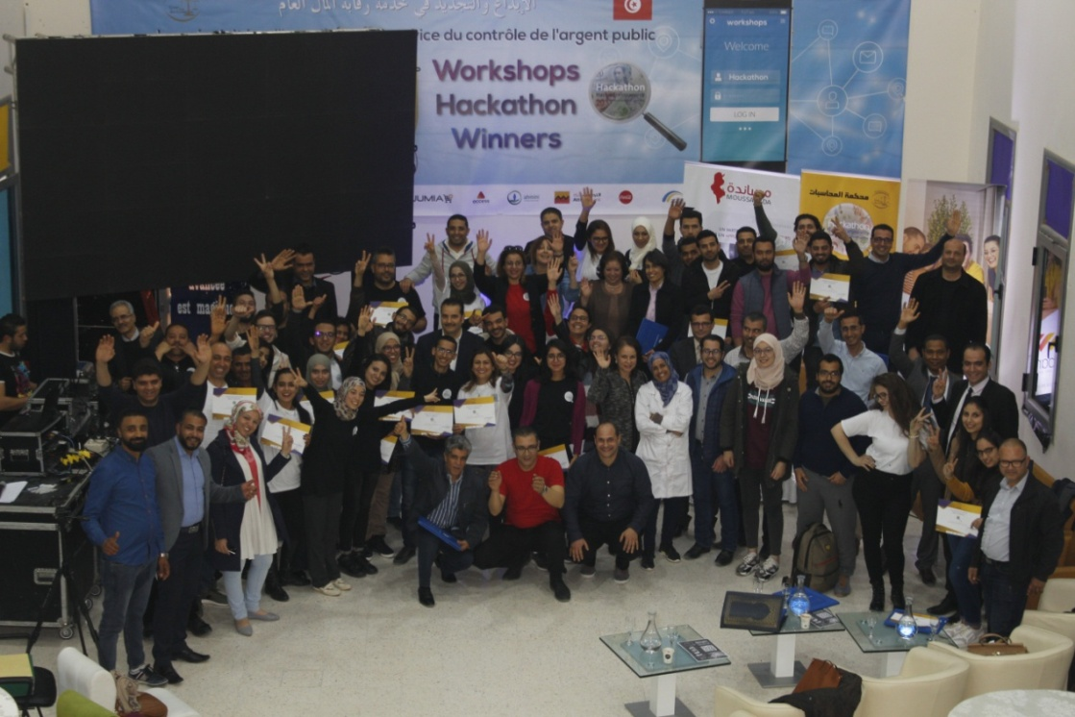
Group photo: Hackathon Sfax (March 17, 2019)
Other regional Hackathons were held in 4 other cities, Sousse (22-24 March 2019), Gafsa (5-7 April 2019), Jendouba (12-14 April 2019) and Tunis (19-21 April 2019).
Since March, we are living with the “Hackathon Fever”, it is a kind of fever we do not wish to recover from. On the contrary, we wish to “contaminate” our environment with it.
The Hackathon is contributing to reach a strategic objective of consolidation of CoA’s position in its environment (Strategic Plan 2016-2020). Furthermore, through Hackathon and its outcomes, the court succeeded in realizing progress in the three objectives of ISSAI 12 « The Value and Benefits of Supreme Audit Institutions – making a difference to the lives of citizens », (i) Strengthening the accountability, transparency and integrity of government and public sector entities, (ii) demonstrating ongoing relevance to citizens, parliament and other stakeholders, (iii) being a model organization through leading by example.
One of the immediate positive effects of the five regional Hackathons is the increase of followers on CoA’s official page on Facebook from 900 to 6100 followers.

The 15 winners of the regional Hackathons had the opportunity to compete between each other in the final 24-hour Hackathon on June 22- 23, 2019 in Hammamet (Tunisia). The three best projects won cash prizes offered by sponsors from the private sector, while a 4th team, the jury’s favorite one (Coup de Coeur), won Tablets. The pitches were presented in front of a jury composed of ten top managers from both private and public sector, representatives of also civil society organizations’ leaders focusing on Transparency and Accountability in Public Management and democracy enhancement processes. Every pitch lasted for five minutes followed by five minutes of questions. This took place on June 23, 2019 and was broadcasted in live on two Youtube Channels created for this event.
On the day before, when the 15 teams were hacking and preparing their presentations, 21 other teams (which didn’t win in the 5 regional Hackathons) were presenting their projects in three parallel sessions around the following themes, so that no ideas were lost:
- Decentralization and local authorities: the new role of the CoA,
- Citizen participation in the audit process,
- External communication, vulgarization of audit reports and follow-up of the CoA’s recommendations.
In every session, at the end of each pitch, the audience voted using an online ranking quiz and the results were broadcasted live on the official Facebook page of the CoA. The first and the second projects chosen by the audience of each session won prizes offered by private sector sponsors of the Final Hackathon event.

Some statistics about the Hackathon events are memorable:
- Number of online subscribers as Hackers in the 5 regional Hackathons: 709 subscribers.
- Number of effective participants in regional Hackathons: 219 participants.
- Number of teams: 42 teams.
- Participation rate of women in hackers population was about 40%.
- Number of participants in the Final event: about 300 (teams, organizers, sponsors, jury, guests inclusive).
- Total number of teams in the final event: 36 teams.
- Number of views of the live videos of the event: 7166 views.
- Number of followers of the official Facebook page of the CoA has increased from 900 before the Hackathon, to 6100 followers.

The story is to be continued with some of the innovative projects that will be incubated by interested partners and sponsors to help participants in setting up startups…

Our Hackathon is a success thanks to a great team. This article is dedicated to all its members. Hackers (especially fifty participants in the Sfax Hackathon), our stakeholders and partners, sponsors, organizers from the World Bank and from CoA, mentors, members of jury and more.

Mouna MSEDDI, Magistrate and President of the regional chamber of CoA- Sfax,
Court of Accounts of Tunisia
Anis MASMOUDI, Magistrate at the regional chamber of CoA – Sfax
Court of Accounts of Tunisia and Coordinator of Hack4Transparency_Sfax (15-17 March 2019).

Tunisia, July 05, 2019

