***Sub-Committee in 2016 – 2019***

**according to**

**INTOSAI Strategic plan 2017 – 2022**

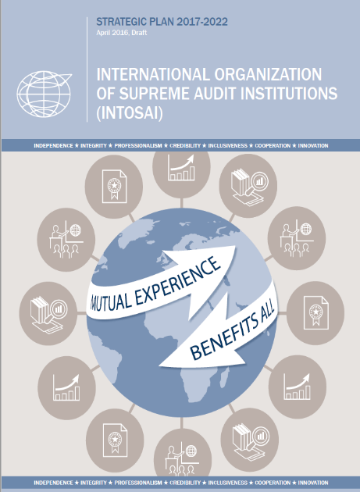

**and its**

**“Key strategies to achieve goal 2**

**and strategic objectives #3”**

**…continued promoting peer reviews**

**as capacity development tool**

**and facilitated the exchange of best practices**

**and access to relevant communities of practice**

**in the field.**

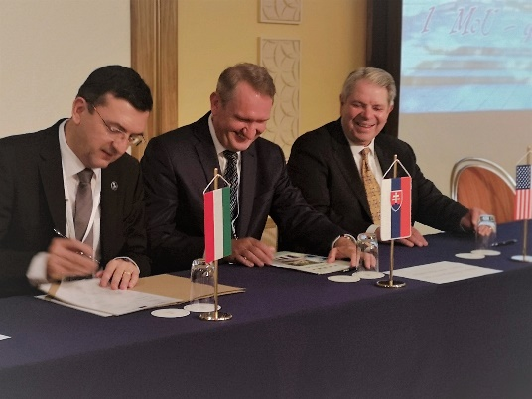

**Sub-Committee members**

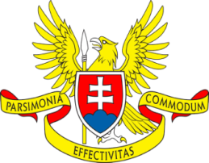 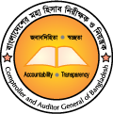

**[](http://www.riksrevisionen.se/en/Start/)** C:\Users\GAL\Pictures\SAis logo\ECA.png

  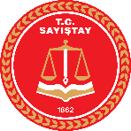

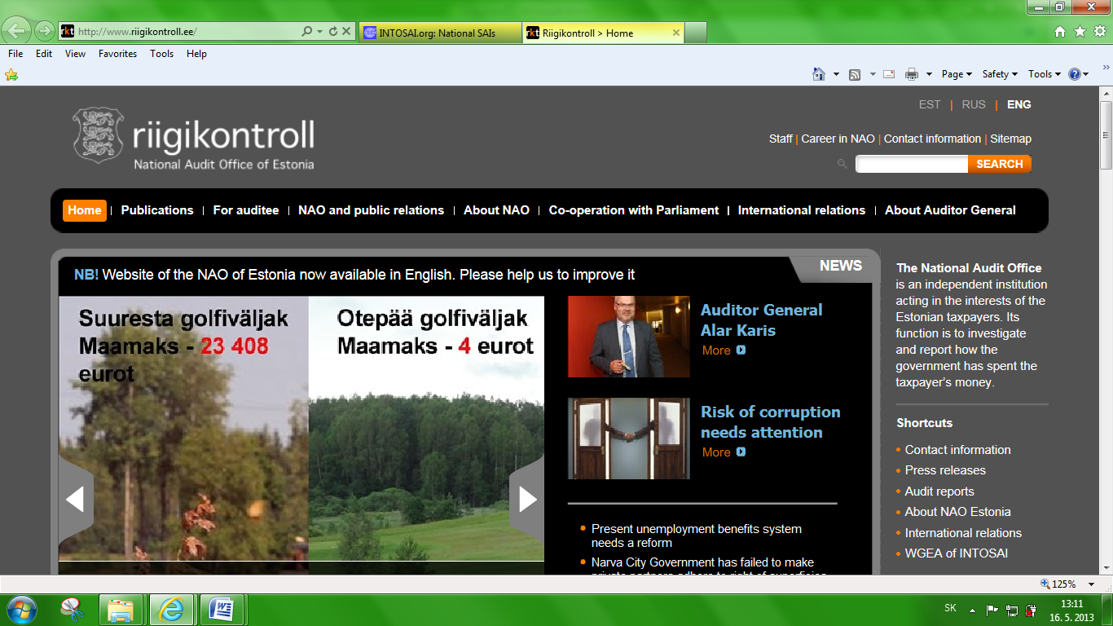 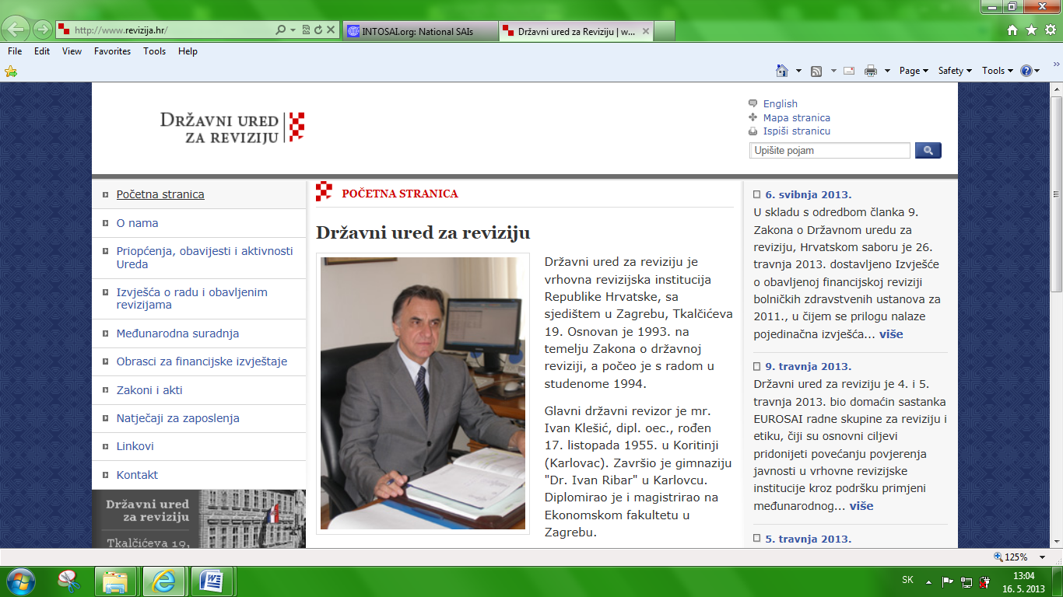

 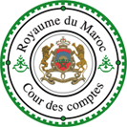

**C:\Users\GAL\Pictures\znaky NKI\Peru.png**

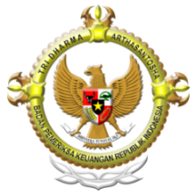

** **

[**http://intosaicbc.org**](http://intosaicbc.org)

***Flyer made by SAI of Slovakia, Subcommittee Chair***

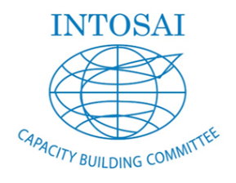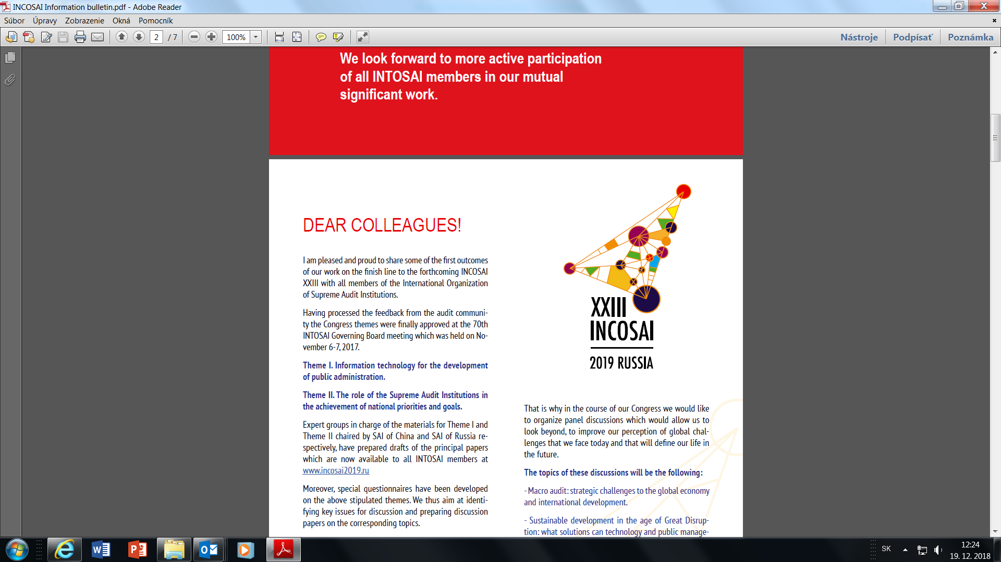

**Sub-Committee**

**on Peer Reviews**



**23. – 27. September 2019**

**Manezh Exhibition Hall**

**Moscow**

Peer reviews

uniting

the world

of INTOSAI

**Partners & contributors sought for**

**Paper on peer reviews**

This activity will put together the current knowledge within INTOSAI community. The project is spread over more than two years and it should culminate by a release of a publication in electronic format in 2021 in three INTOSAI languages – English, French and Spanish.



**Milestones**

**IX – XII / 2019 structure and content**

**I – VI / 2020 partners’ selection**

**VII 2020 – VI 2021 / contributions and translations**

**VII – XII / 2021 publication**

**Global peer review survey**

The peer review global survey was organised almost every year until 2017. Since 2012, six surveys were performed. The survey results feed the pages of the CBC web site, dominantly the library file with occasional feature article in other INTOSAI electronic media.

The next survey is planned for 2021.



**Milestones**

**IX – XII 2020 survey questionnaire re-assessemnt**

**I – III 2021 execution**

**IV – VI 2021 publication**

***Interested parties should contact*** [***info@nku.gov.sk***](mailto:info@nku.gov.sk)

**Latest activities**

**Peer review conference 2018**

**“Motivating and equipping SAIs**

**to carry out peer reviews”**

The global conference provided robust agenda with 19 presentations, round table discussions and several panel-led deliberations. Over 47 INTOSAI member organisation and one hundred delegates participated covered heavily live in social media.

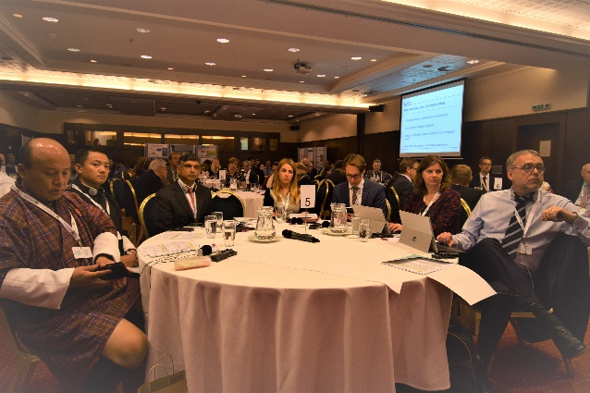

**Survey 2017 and 2019**

Peer review is usually welcomed by participants as opportunity to:

* **confirm good work** done by the reviewed SAI;
* **uncover gaps** in the reviewed SAI activities;
* get ideas for **continuous improvement**;
* **build the SAIs** as modern institutions;
* **exchange knowledge and experience.**

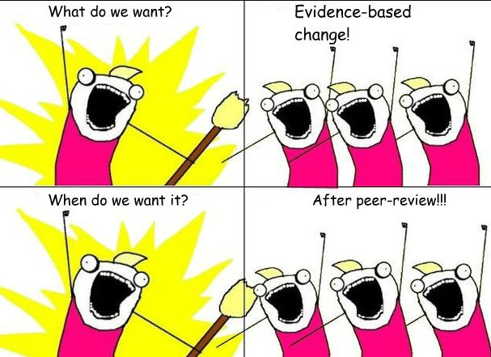

***For more information, follow the INTOSAI electronic media.***

**Partners & contributors sought for**

**Training seminar**

**Getting ready for a peer review**

It will bring together SAIs with rich experience in peer reviews as a peer reviewer along SAIs that wish to have peer review preformed in their organisation. The seminar to be held in June 2021.

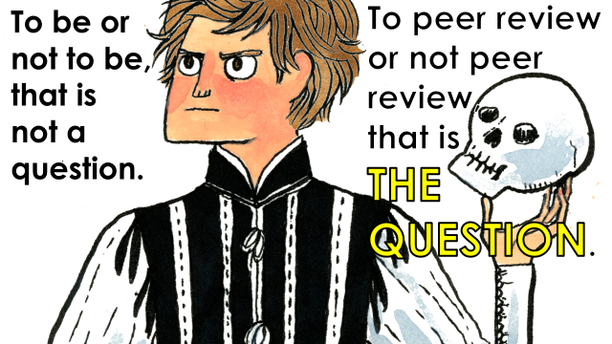

**Milestones**

**X / 2019 – VI / 2020 structure and content**

**VII – VXII / 2020 invitations sent out**

**I - III / 2021 – III / 2021 preparation**

**VI / 2021 seminar**

**Review of ISSAI 5600 and its Annex**

The ISSAI framework suggests ISSAI 5600 should be reviewed every three years. The day-to-day life showed that interval 6 – 9 years appears adequate.

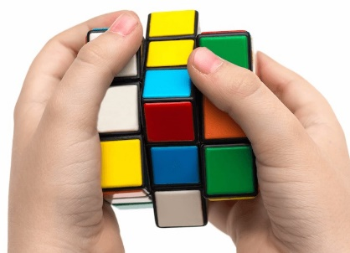

**Milestones**

**I – XII / 2020 reassessing the structure and content**

**I – XII / 2021 work on standard**

**I – II / 2021 FIPP**

**X – XII / 2022 INCOSAI**

***Interested parties should contact*** [***info@nku.gov.sk***](mailto:info@nku.gov.sk)